1. let vs const – Bug in Production In a dashboard app, a developer used const for a variable that stores the logged-in user’s role. Later, the role needs to be updated when the user switches accounts without reloading the page.
Question: Why does this cause an error, and how would you refactor the code using let and const correctly?
const creates a variable binding that cannot be reassigned. If the application stores the logged-in user’s role in a const variable and later tries to change it when the user switches accounts, JavaScript throws a TypeError.
Example of the problem:

This fails because reassignment is not allowed.
Correct refactor
Use let when reassignment is expected, and const when the binding itself must remain stable.
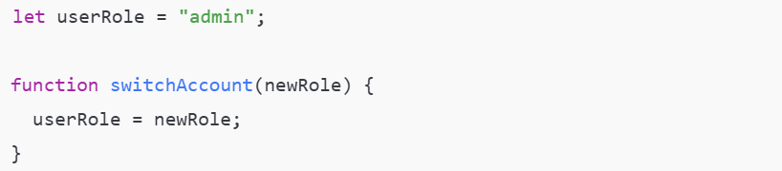
If using an object, keep the reference constant and mutate its properties:
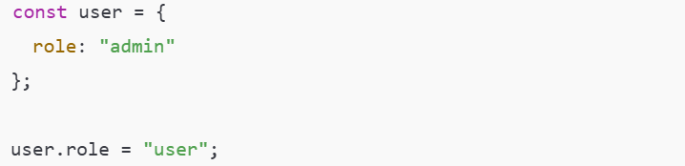

2. Block Scope Debugging Issue A loop creates buttons dynamically, and each button should log its own index when clicked. However, all buttons log the same index value.
Question: How does replacing var with let fix this issue, and what is happening internally with block scope?
The bug
All dynamically created buttons log the same index value when clicked.
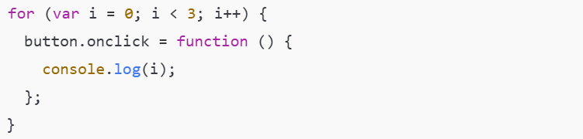
var is function-scoped, not block-scoped. All callbacks share the same i. By the time a button is clicked, the loop has already finished and i contains the final value.
Why replacing var with let fixes it
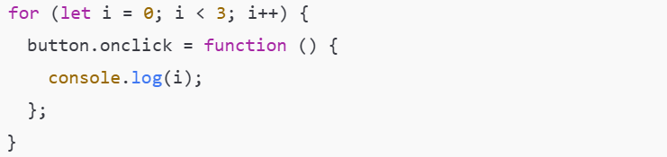
let is block-scoped. JavaScript creates a new lexical environment for each iteration, giving every callback its own copy of i.

3. Error Handling in API Response You are consuming an API that sometimes returns null instead of an object. The app crashes when trying to access response.data.user.name.
Question: How would you handle this error using try...catch, and how would you debug this issue in the browser?
The crash
The application assumes the API always returns a full object.
If data or user is null, this causes a runtime error.
Handling with try...catch
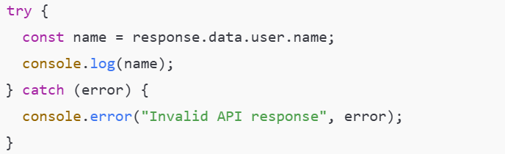
Defensive alternative
Debugging in the browser
- Open Developer Tools
- Inspect the Network tab to view the API response
- Log the full response object
- Use breakpoints to inspect nested properties before access

4. Custom Error for Business Logic In a payment module, the amount should never be negative or zero.
Question: How would you throw a custom error, catch it, and display a user-friendly message without breaking the application flow?
Throwing a custom error
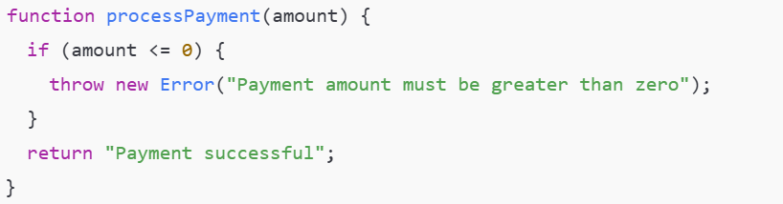
Catching and displaying a user-friendly message
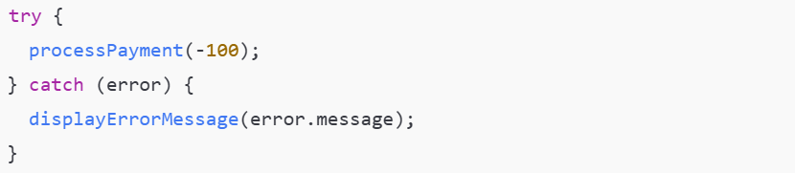
This enforces business rules while keeping the application stable.

5. Generators for Large Data Processing You are processing a huge list of logs, but loading everything into memory slows down the app.
Question: How would you use a generator function to process one log at a time, and why is this better than a normal loop?
Generator implementation
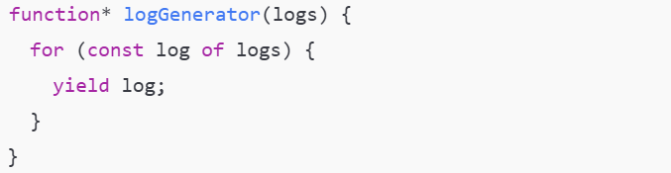
Usage

Why this is better
Generators process values lazily. Only one log exists in memory at a time, improving performance and reducing memory usage compared to loading the entire list at once.

6. Iterators in a Custom Object You created a custom object representing a playlist, and you want to loop through songs using for...of.
Question: How would you implement an iterator using Symbol.iterator for this object?
Implementing Symbol.iterator
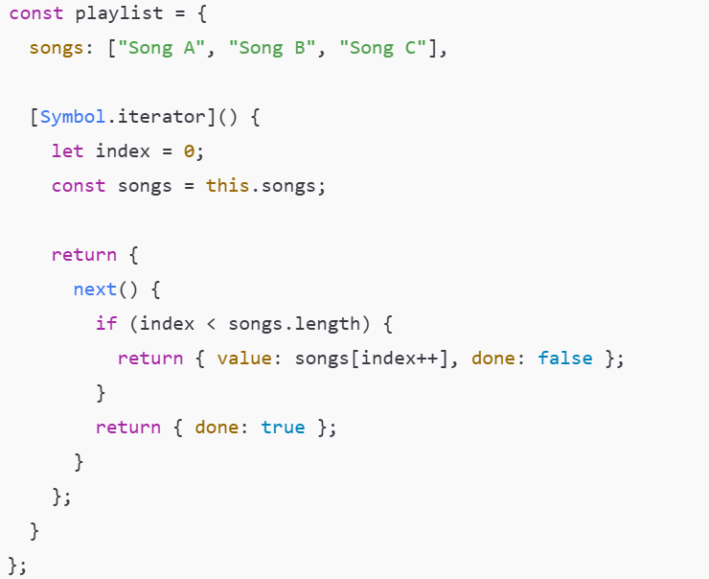
Usage


7. Import / Export Debugging Scenario A utility function is exported from utils.js, but when imported into app.js, you get undefined.
Question: What are the common mistakes with named vs default exports, and how would you debug this issue?
Common mistake: Named vs default export mismatch
Incorrect import:
Correct import:
Default export confusion
Correct import:

How to debug
- Verify the export type
- Match braces correctly
- Log the imported value
- Check file paths and extensions

8. Functions vs Classes Decision You are building a notification system where notifications have state (read/unread) and behavior (mark as read).
Question: When would you choose a class over a function, and how would you structure this using ES6 classes?
When to choose a class
Use a class when the feature has:
- Persistent state
- Related behavior
- Multiple instances
ES6 class structure
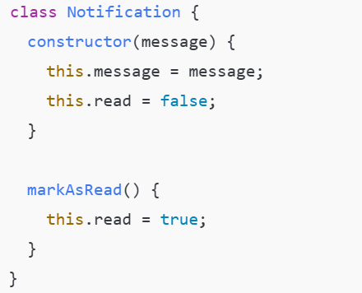
Classes provide clearer structure and better encapsulation for stateful logic.

9. Map, Filter, Reduce – Performance Case You receive an array of orders. You need: only completed orders total revenue formatted output
Question: How would you use filter, map, and reduce together, and why is this approach better than multiple loops?
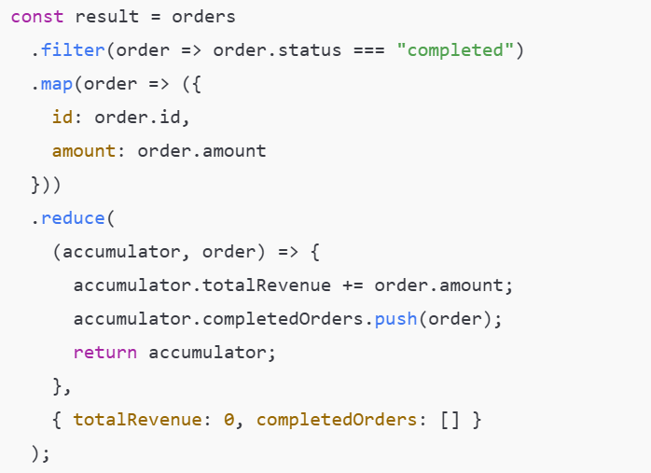
Why this approach is better
- Clear intent
- No manual mutation
- Easier to test and debug
- More maintainable than multiple loops

10. Arrow Functions & this Bug In a class method, an event handler using a normal function loses access to this.
Question: How does converting the function to an arrow function fix the issue, and what is the difference in how this works?
The problem:
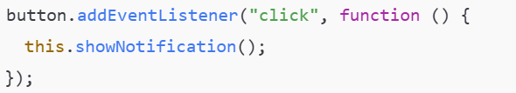
Here, this refers to the button, not the class instance.
The fix
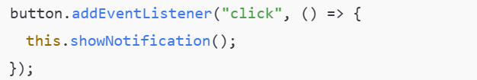
Why this works
Arrow functions do not create their own this. They capture this from the surrounding lexical scope, preserving access to the class instance.

